TACOMA POLICE DEPARTMENT

Intra-Departmental Memorandum

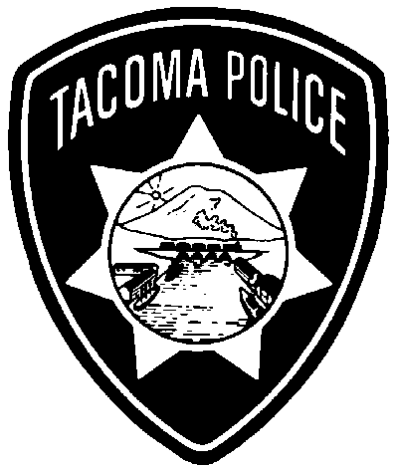

|  |  |  |
| --- | --- | --- |
| **TO:** | Donald Ramsdell  Chief of Police | **ASB #:** 20-003 |
| **FROM:** | Lieutenant Dwayne Joseph  Community Policing Division | **DATE:** February 5, 2020 |
| **THROUGH:** | Captain Fred Scruggs  Support Services Division Commander  Assistant Chief Mike Ake  Administrative Services Bureau Commander | |
| **SUBJECT:** | **2019 PURSUIT ANALYSIS REPORT** | |

The Tacoma Police Department uses the IAPro/BlueTeam database to track all Department incidents, to include Vehicle Pursuits. Each vehicle pursuit is reviewed and evaluated by a field Supervisor, a Shift Commander and the Patrol Captain.

The Tacoma Police Department recognizes that under [RCW 46.61.035](http://app.leg.wa.gov/RCW/default.aspx?cite=46.61.035) (see RCW for legislative language in its entirety), Officers have the legal right and duty to apprehend offenders who flee from the police and present a threat to the public. However, Department members will only engage in pursuits when the necessity to apprehend the violator outweighs the danger posed to the public. Every Department member engaging in a pursuit must be able to articulate what conditions were present that justified the pursuit.

Tacoma Police Policy defines a vehicle pursuit as an active attempt by an Officer to apprehend a suspect who willfully fails to immediately bring his or her vehicle to a stop, and drives in a reckless and evasive manner while attempting to elude a pursuing police vehicle.

The following analysis of the 2019 Vehicle Pursuits is based on information retrieved from the IAPro database.

| **Pursuits** | **2019** |
| --- | --- |
| Total Pursuits | 12 |
| Number of officers involved | 21 |
| Most frequent hours 0001-0200 | 3 |
| Policy Compliant | 10 |
| Policy Non-Compliant | 2 |
| Pending | 0 |
| Accidents during pursuit | 5 |
| Injuries: Officer | 0 |
| Injuries: Suspects | 0 |
| Injuries: Third Party | 0 |
| Traffic Offense-Criminal | 1 |
| Felony - Property | 1 |
| Felony - Person | 10 |

Twelve (12) pursuits took place within the City of Tacoma for 2019. One of those pursuits was assisting another agency, the Lakewood Police Department.

**Reason Initiated:**

|  |  |  |
| --- | --- | --- |
| Assist outside agency | 1 | 8% |
| Felony-Person | 10 | 74% |
| Felony Property | 1 | 8% |
| Traffic – criminal | 1 | 8% |
| Traffic – non-criminal | 0 | 0% |

All 12 vehicle pursuits were entered into BlueTeam and reviewed by Department supervisors. Ten out of the 12 TPD pursuits were deemed to be within Department Policy. The two incidents that were not within Department guidelines were:

1. Officer initiated pursuit of reckless DUI suspect.
2. Officer assisted Lakewood Police Department with a vehicle pursuit.

Eleven of the 12 vehicle pursuits (92%) took place on clear days/nights.

There was no in-car camera video available in any of the 12 pursuits.

**Event that Concluded the Pursuit:**

|  |  |  |
| --- | --- | --- |
| Terminated/Canceled | 1 | 8% |
| PIT Maneuver | 2 | 17% |
| Suspect stopped vehicle | 4 | 33% |
| Suspect vehicle crashed | 4 | 33% |
| Suspect vehicle eluded pursuit | 1 | 8% |

In four vehicle pursuits (33%), the suspect stopped on their own accord. In two vehicle pursuits (17%), the officers used the PIT Maneuver. Four suspect vehicles crashed (33%), and one suspect vehicle eluded the pursuit.

**ANALYSIS**

The number of pursuits that the Department was involved in stayed the same; 12 in 2018 and 12 in 2019.

One of the pursuits was terminated in 2019, and one was terminated in 2018.

Of the 12 vehicle pursuits, 1 occurred on day shift, 2 occurred during swing shift, and 9 occurred during graveyard hours, to include swing shift/graveyard shift overlap.

|  |  |  |
| --- | --- | --- |
| **Shift** | **2018** | **2019** |
| Day Shift | 1 | 1 |
| Swing Shift | 3 | 2 |
| Graveyard Shift  (including Swing Shift overlap) | 8 | 9 |
| **Total** | **12** | **12** |

**Annual Review of the Department’s Vehicle Pursuit Policies and Reporting Procedures (CALEA 41.2.2)**

During the annual review of all vehicle pursuits, the Department’s current Policies and Procedures were reviewed to include the reporting procedures. At this time, the Department is in compliance, and we have reviewed our Pursuit Policy and reporting procedures. All annual training needs have been addressed. There is no need to make changes at this time.

**RECOMMENDATIONS**

In 2020, the Department will continue to provide departmental training that is required per CALEA. The Department will be providing EVOC training to Operations personnel. The Department will continue to monitor accidents involving on-duty police employees and address the current hazards of driving police vehicles.

DJ:man